**💡 Nuclino Tip:** This [pinned](https://help.nuclino.com/87e7880f-pin-an-item) page is the first page your team members will see when they join this workspace. This is a perfect opportunity to give an overview of your project and provide some guidance on where to find what.

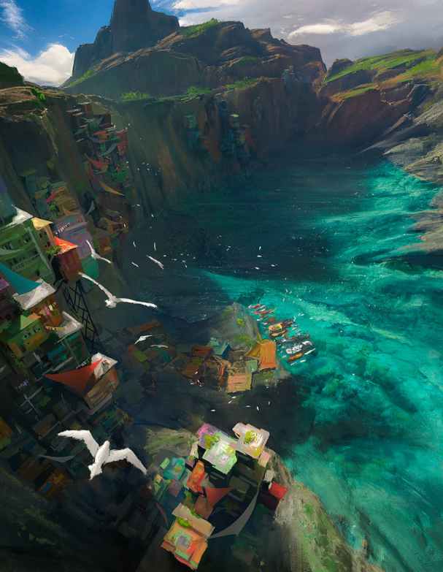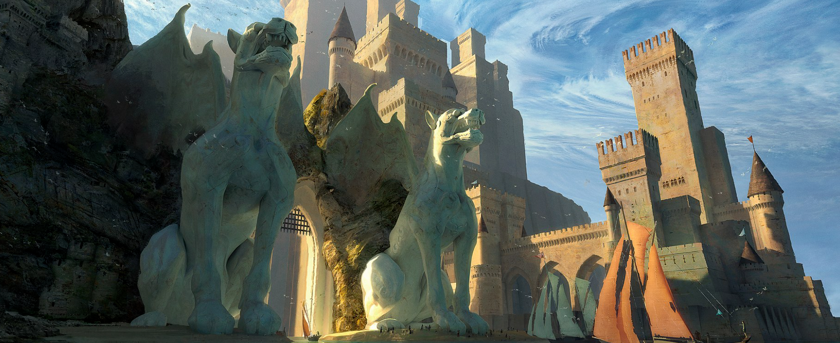

# Working title

The Younger Scrolls V

# Elevator pitch

We're developing an open-world RPG game set in a medieval fantasy world inspired by European folklore. Its gameplay is strongly story-driven and based on the best-selling book "Earl of the Rings". It's "The Witcher" meets "Dark Souls" meets "Game of Thrones".

# Concept

## Overview

* **Genre:** Open-world RPG / Action
* **Target audience:**
  + **Age:** 15-30
  + **Gender:** Male/Female
  + ...
* **Monetization:** Freemium, with in-game micro-transactions
* **Platforms & system requirements:**
  + ...
  + ...
  + ...

## Theme and setting

The Younger Scrolls V is a role-playing game set in a historical fantasy version of medieval Europe. The player takes on the role of the Chosen One and gets to explore an open world of 450 square kilometers. While the geographic setting of the game is historically accurate, the game features many supernatural elements.

Learn more about the <Not authorized to access link>, <Not authorized to access link>, and <Not authorized to access link> of the game.

...

# Project scope

## Our team

* **Dev:** [@Sonia](https://help.nuclino.com/988f802d-mention-a-team-member), [@Paras](https://help.nuclino.com/988f802d-mention-a-team-member), [@Ruben](https://help.nuclino.com/988f802d-mention-a-team-member)
* **Design:** [@Matt](https://help.nuclino.com/988f802d-mention-a-team-member), [@Antonio](https://help.nuclino.com/988f802d-mention-a-team-member)
* **Art:** [@Erica](https://help.nuclino.com/988f802d-mention-a-team-member)
* **QA:** [@Darren](https://help.nuclino.com/988f802d-mention-a-team-member)
* ... [@Name](https://help.nuclino.com/988f802d-mention-a-team-member)

## Budget

|  |  |
| --- | --- |
| **Spend Type** | **Planned** |
| ... |  |
| ... |  |

## Timeline

* ...
* ...
* ...

💡**Nuclino Tip:** You can easily embed charts and diagrams directly into Nuclino. Here's an example – to create your own diagram, use [Miro](https://help.nuclino.com/30cb20d7-embed-boards-from-miro), [Lucidchart](https://help.nuclino.com/a5bfb729-embed-diagrams-from-lucidchart), [Gliffy](https://help.nuclino.com/8d28e8a1-embed-diagrams-from-gliffy), [Google Drawings](https://help.nuclino.com/4f6c2d8f-embed-diagrams-from-google-drawings), or [Diagrams.net](https://help.nuclino.com/42fc3c5b-embed-diagrams-from-draw-io) and follow our [guides](https://help.nuclino.com/bc08e965-diagramming) to embed them.

<https://miro.com/app/board/o9J_lPSTxjw=/>

*Artwork credit:*[*Stephane Wootha Richard*](https://commons.wikimedia.org/wiki/User:Artofwootha)